**Pig foot Souse**

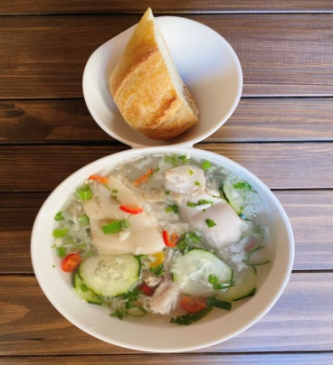

**INGREDIENTS**

6 pieces Pig's feet boil Boil pig feet in a pressure cooker or large pot. Add garlic cloves and a little salt to the boiling water.

3 cups Water

1 tbsp Salt

2 tbsp Lime/ lemon juice Use freshly squeezed fresh lime or lemon juice

whole Fresh hot peppers Based on your threshold

1 tbsp Parsley chopped

1 tbsp Thyme leaves chopped

3 Cloves Garlic minced or chopped

1 head Scallion chopped

**METHOD**

Throw out all the water, remove imperfections, and rinse.

In a bowl, combine water, onions, garlic, salt, lime juice, parsley, thyme, scallions and peppers.

Take a spoon and gently crush ingredients against the sides of the bowl, so that they can commingle better and distribute their flavors

NOTES

**Instructions for boiling souse**

Wash pig’s feet with lemon and rinse under running water in a large bowl.

Then Put pig feet in a pot with water cloves of garlic, some thyme and a little salt.

Boil pig’s feet for 90 minutes. Make sure that pig feet is soft but not too soft. It should be a little firm so that it doesn’t fall apart.

Let the pig’s feet cool down a little.

Throw out all the water, remove imperfections, and rinse.